**Create NuGet CI/CD pipeline**

Create new project in Azure DevOps.

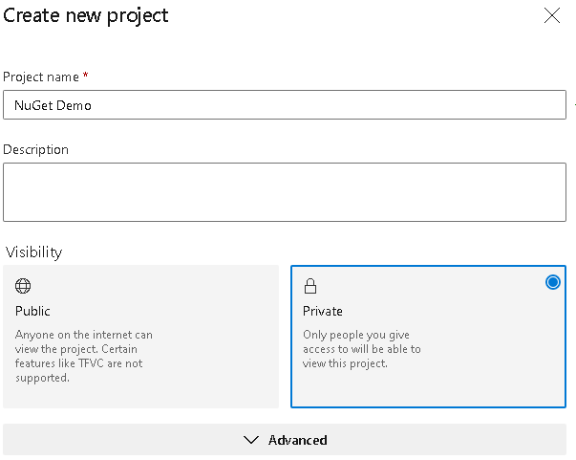

Clone empty repo

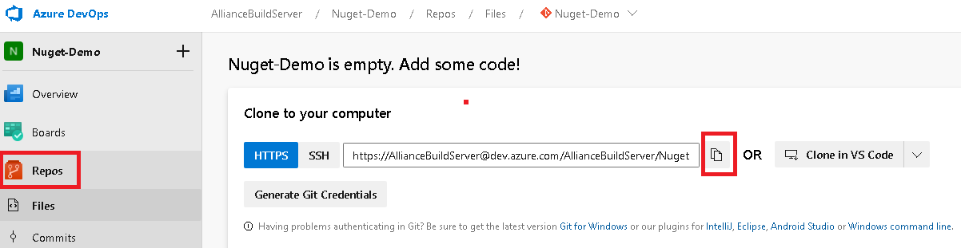

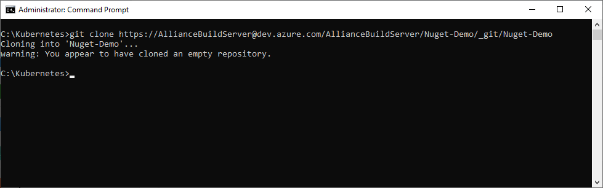

Open the Nuget solution and check that the build compilation is working with no errors.

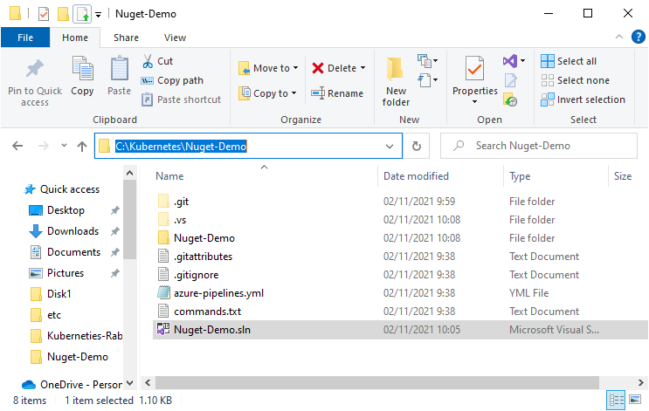

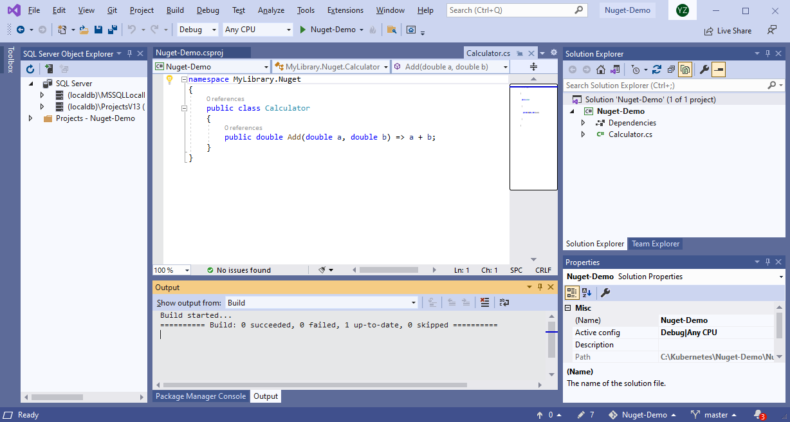

Commit and push to repo on Azure DevOps.

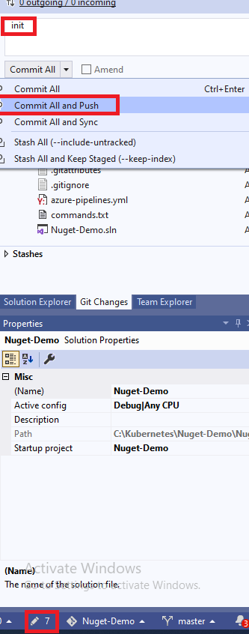

Now the reop in Azure DevOps contains the files.

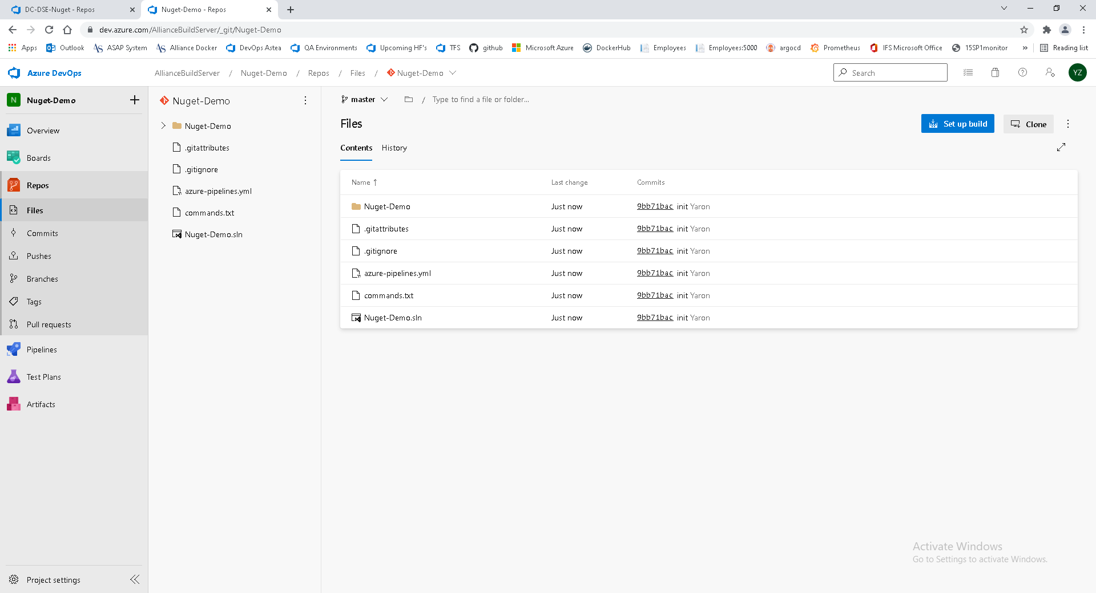

Go to Artifacts and create new feed

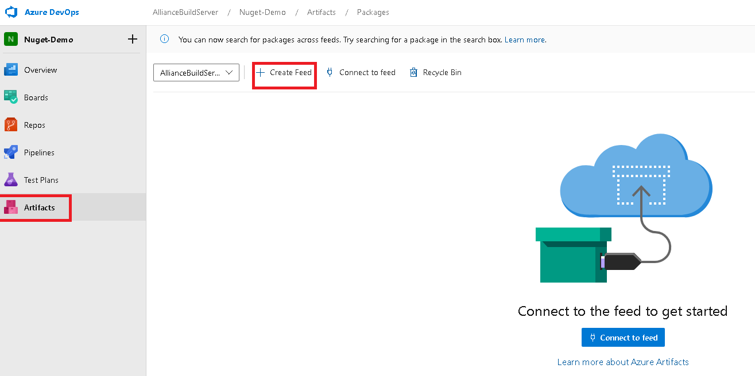

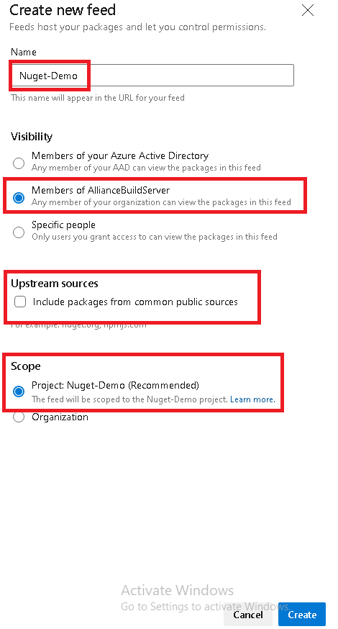

Create new pipeline

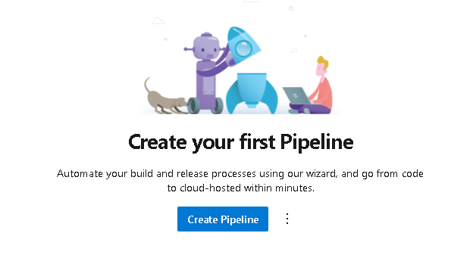

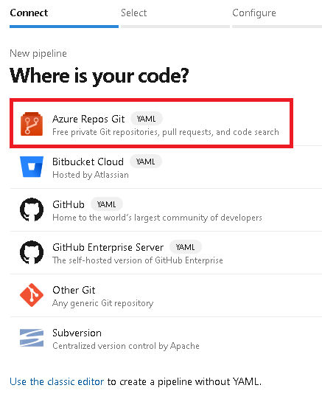

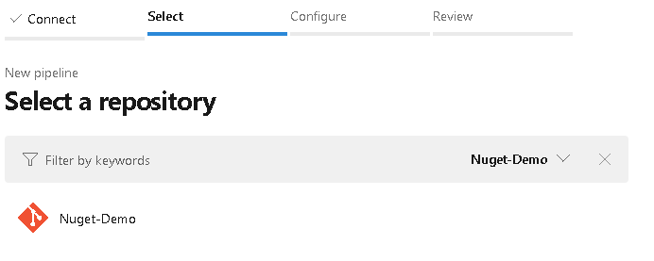

Remove the ‘push’ task

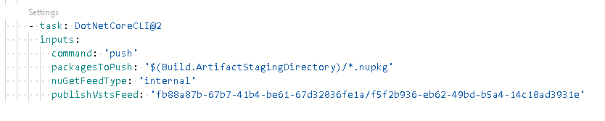

Click show assistant and select .NET Core



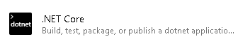

Select nuget push

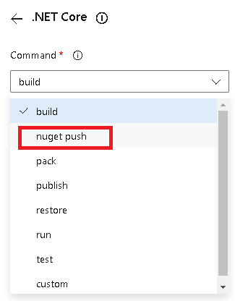

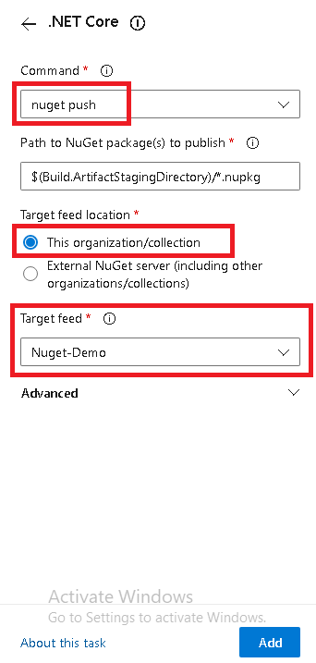

Push task added to pipeline script

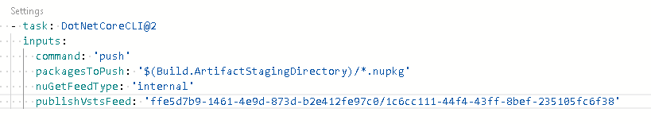



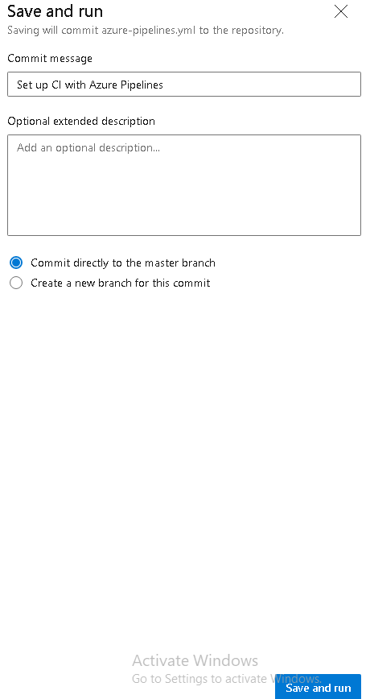

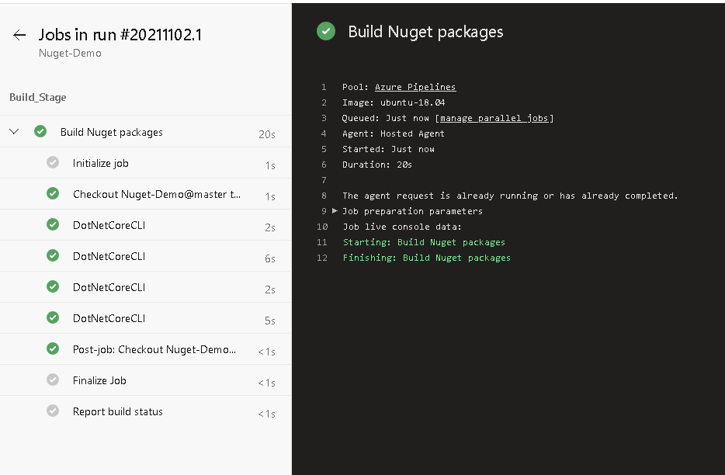

Connect to feed.

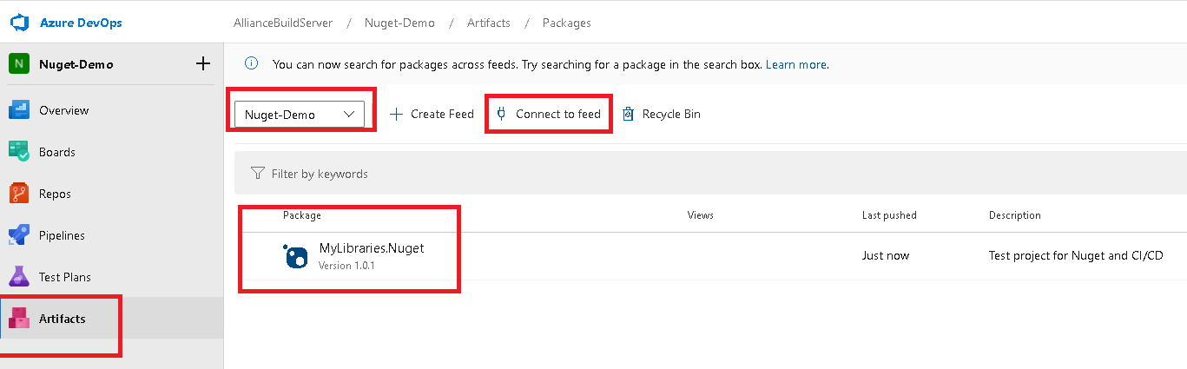

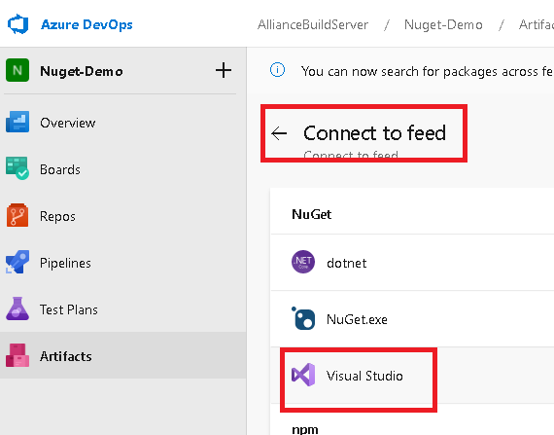

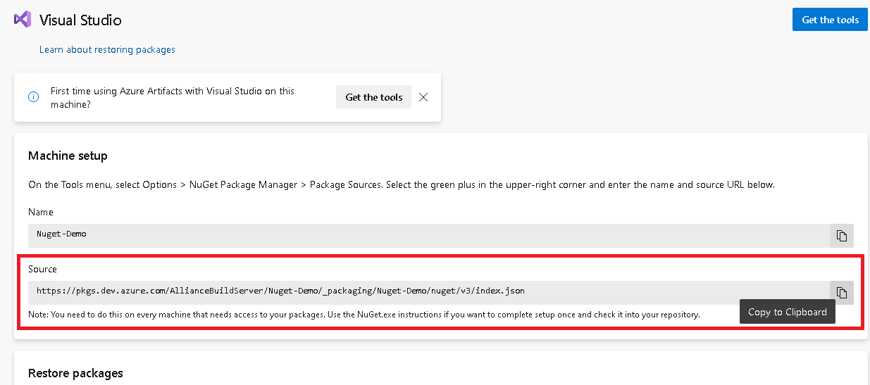

URL for Nuget pakage.

<https://pkgs.dev.azure.com/AllianceBuildServer/Nuget-Demo/_packaging/Nuget-Demo/nuget/v3/index.json>

VS 2019 -> Tools -> NuGet Package manager -> Manage NuGet Packages for Solution

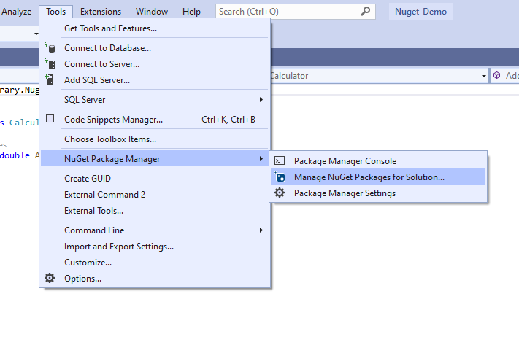

Click Settings

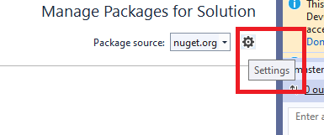

Clcik + -> Name and paste the Source -> Update

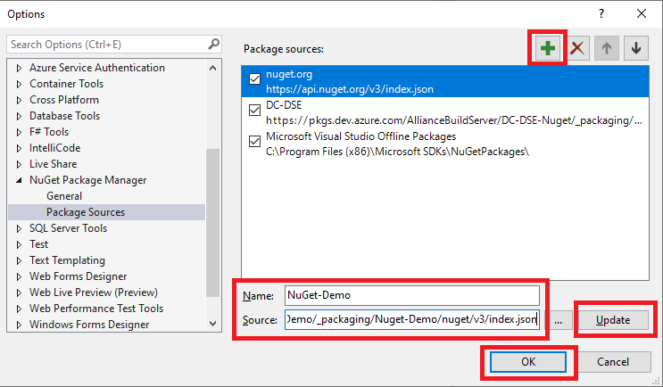

OK

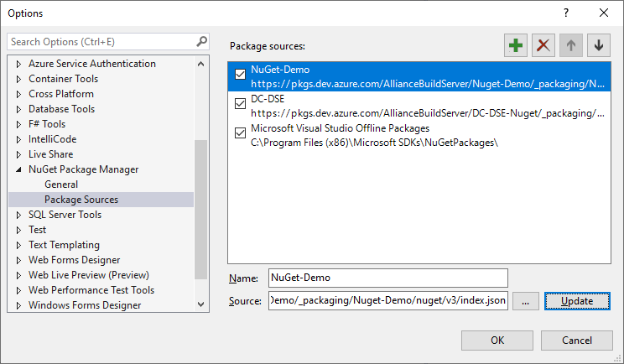

Update the package version and push to Azure repo

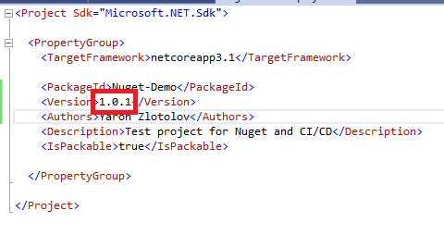

New pipeline automatically generated after pushing the code

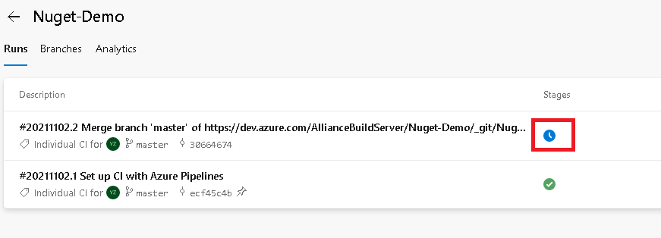

Nuget package is ready in the feed

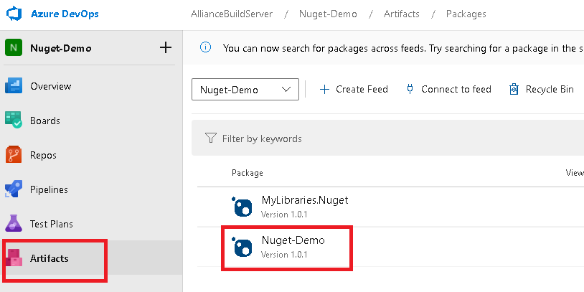

Back to NuGet Package manager



Refresh

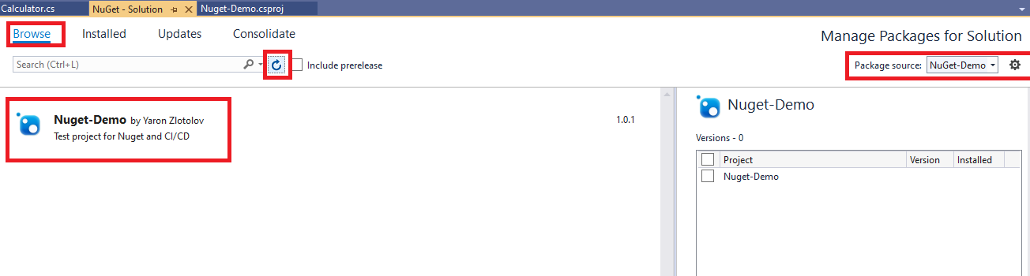

Done!